Sadirov Farrukh 12184773

Big Data analysis

Prof Kakani Vijay

In this final assignment I learned how to utilize existing datas and prepare clean them for anaysis also using surveys to conduct marketing research which can be beneficial in the future.

So simply what was done is I chose topic about “How buying behavior of online costumers changed before and after Covid-19”. I searched datasets and surveys from the internet to utilize it using lessons I learned in the class. I found out that python is quite convenient and user friendl for preparing and analysing data to process for further procejures.

Also for the visuals I used Excel to simply understand how it can work and to see and experience everything taught in the class. Here are screenshots

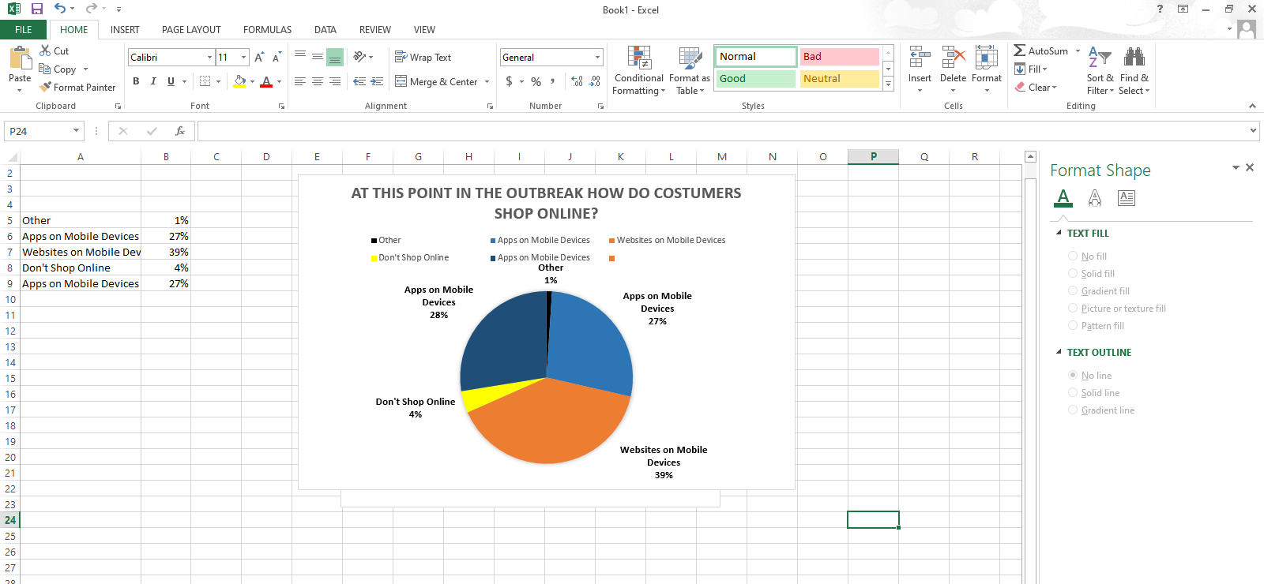

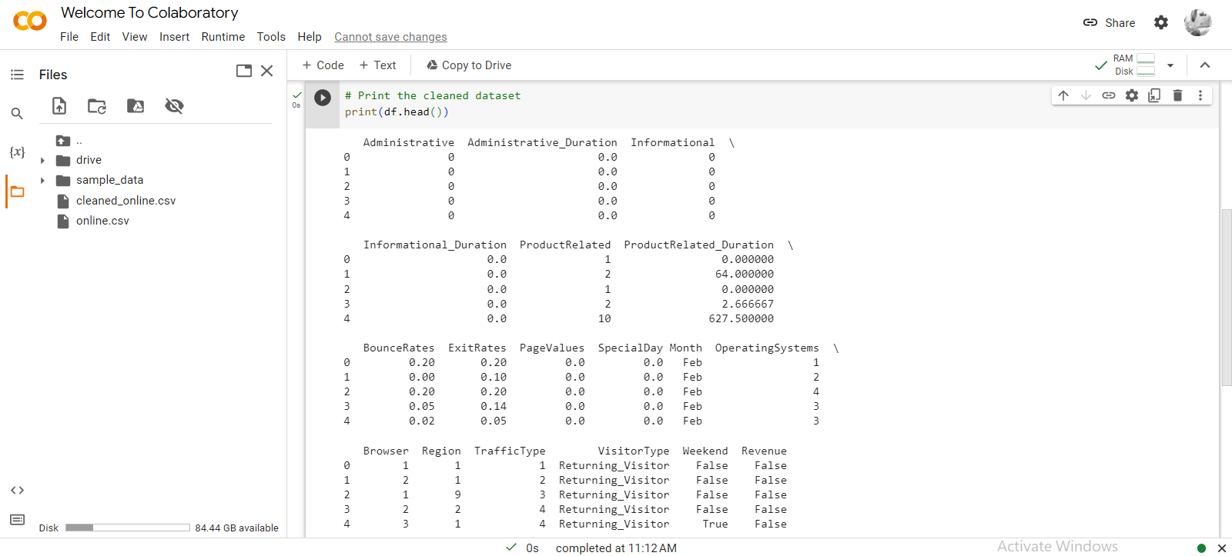

To summarize I can say this assignment was really helpful for me to understand data analysis tools more in detail.